Assignment Brief: Stealth Game –   
Artificial Intelligence for Games

Overview:

Watch the Youtube video for the game *“Smooth Criminal*”: <https://www.youtube.com/watch?v=3HhB6JzjtwE>

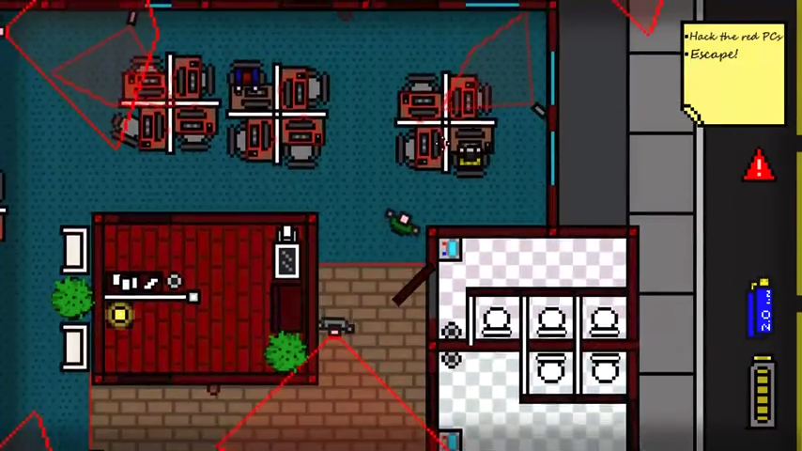

Create a 2D top-down interactive stealth game.

The player character should have goals or target, such as hacking the computers or sealing an object. The NPCs in the game should patrol and guard the target from the player.

Each guard (or NPC) should have a ‘cone of sight’ which indicates whether the guard can ‘see’ the player. If the player ever enters a guard’s cone of sight, then the alarm is raised.

Once the alarm is activated, the players location is noted, and all guards will converge on the player attempting to catch (or shoot?) them. While the player remains visible to any one guard, all guards will know the location of the player.

If the player goes out of sight after raising the alarm, the guards should convincingly check the last known location of the player before resuming their patrol route.

The player must navigate through the game world, avoiding being seen or caught by the guards. Once they player reaches the goal (for example, hacks all the computers or opens the safe) they must reach the exit location to end the game.

Implementation:

Create a simulation with NPC guards that patrol your level. The guards should implement an appropriate NPC AI strategy.

When the player enters a guard’s area of visibility, the guard informs all other guards of the players location. Each guard should then form an appropriate strategy to apprehend the player. For example, you could have each guard acting individually, or have all guards attempt to catch the player by working as a group.

When the player is no longer visible to any guard, the guards should search for the player based on their last known location.

Pathfinding algorithms must be used for the NPCs. You may choose to implement a chess board-like series of cells for each guard to move to, or use each room in your map as a node in a pathfinding graph.

Optional Additions:

Feel free to expand on these base requirements and improve your simulation in any way you prefer.

Additional features you may wish to add could include:

* Blackboards:   
  When a guard detects the player it writes a message to the blackboard. Any other guard nearby could read the message on the blackboard and be aware of the player, even if they are not able to detect it directly.
* Cameras:  
  Add security cameras to your game that can also detect the player. The player may have the option of hacking cameras to disable them.
* Modified behaviours once detected:  
  Have your guards change their behaviour once the player is detected. Perhaps they systematically search for the player, or patrol a randomized route.
* Other Features:  
  The video of the game “*Smooth Criminal”* demonstrates many additional features. For example, if the player kills a guard, other guards may discover the body and raise the alarm. Watch the video and see if you can add any of the features shown.